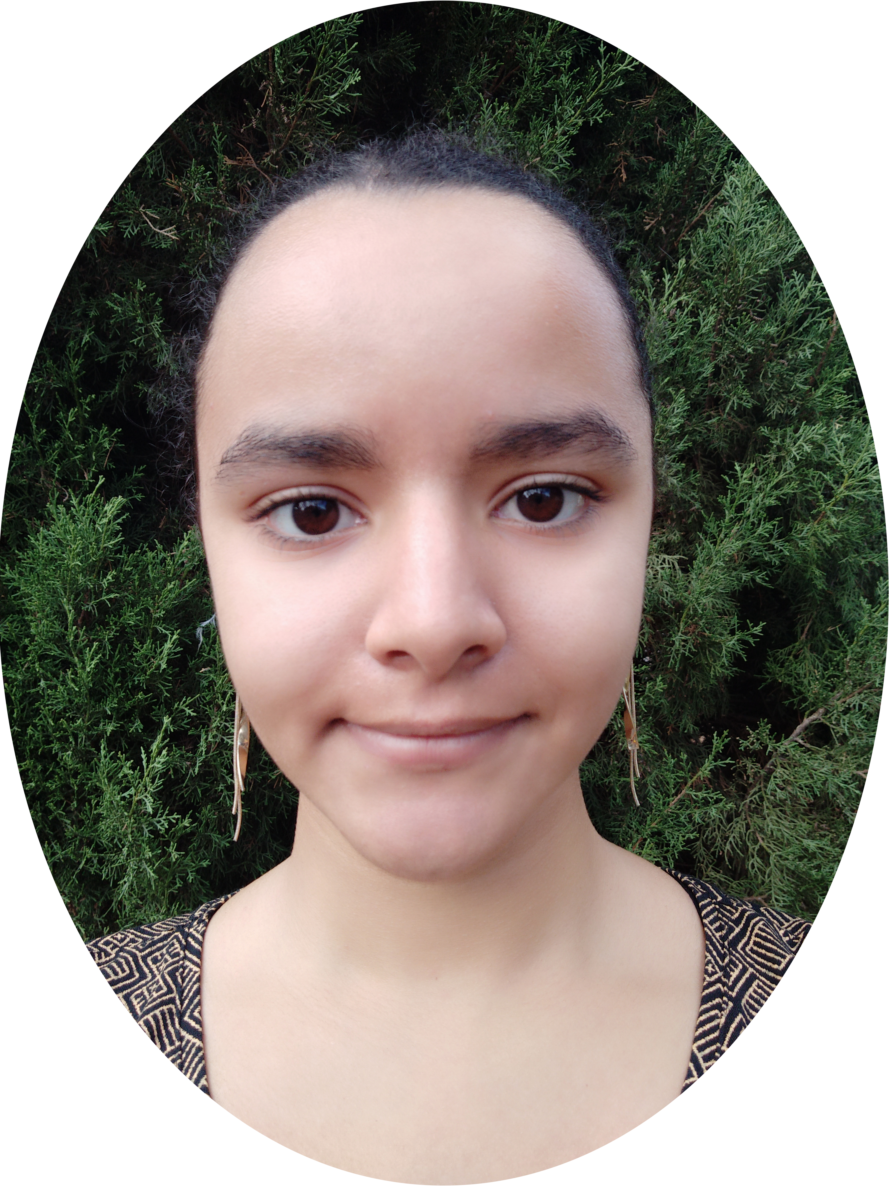
Application for an IT internship
2 - 3 months from June 1, 2020

Ambre LAMOUCHI  21 years  07 83 35 16 86  271 av. Puech de Massane  34080 Montpellier  lamouchiambre@gmail.com  computer skills | Education  2019- in progress License 3 Cursus Master Engineering - Computer Science  University of Montpellier  - Study of preferences in the expression of quantification  - Supervised research work over 1 year  2017-2019 License 1 & 2 in Cursus Master Engineering -Informatics  University of Montpellier  - Visualization of Mandelbrot Fractals  - 3-month programming project  - Realization of a Mandelbrot Fractal representation software in C ++ and Opengl  2016-2017 1st year of Preparatory Class in Physics Chemistry and Engineering  Joffre High School, Montpellier  2016 Bachelor of Science Mathematics Honours  Jean Monnet High School, Montpellier
Office: Pack office, pack Microsoft, Linux, LaTeX  Modelization : UML  Software :  Java, C++, C, Python, Scheme, OracleSQL, OpenGL, MySQL  Web :  HTML5, CSS3, PHP 7, Javascript  Three.js  Center of interest  Theater  Member of the company "Mandragor" participation in festivals and theatrical performances from 2006 to 2016. | IT experience  2019 August Initiation to research internship: Artificial Intelligence  Centre International de Mathématiques et Informatique (CIMI), Toulouse  - Learning Artificial Intelligence techniques.  - Understanding of societal challenges and ethical risks  2019 June (2 months) Research internship  Laboratoire d’Informatique, de Robotique et de Microélectronique de Montpellier  - Synthesis bibliography on all the projects of "immersive annalytics"  - Development and implementation of a VR visualization program (Occulus GO).  2016 August Research initiation internship: Security  Centre International de Mathématiques et Informatique (CIMI), Toulouse  - Learning the basics of computer security and cryptography  2015 april Ateliers et 2 camps d'informatique  Epitech, Montpellier  - Discovering and learning code through video games  2014 MathC2 + initiation to research mathematical sciences and computer science  University of Montpellier  - Discovery of bioinformatics, programming: introduction to the Python language, use of Arduino
Game Jam :  EduGameJam 2019: "L’oeil de Jean" 4th place  Diploma  2019 - C2i level 1  2016 – Baccalaureate S Mention B | Other experiences  2018 August (1 month) Administrative assistant  Crédit Foncier, Charenton-Le-Pont (94)  - Updating the records of the Implementation service  - Constitution of requests for expertise  2018 June Teaching internship in an application school  Charles Daviler School Montpellier  - Technical assistance and support for teachers  - Implementation of computer art
Langues  French, English, Spanish | Association and Volunteering  2019 Treasurer of the association «Hello World»  - Participation in the organization of the 2019 festisciences  - Financial management of the association  - Realization of a project on deepLearning (creation of the "Threat" machine)  February 19, 2019 Open House Volunteer  - Welcoming students at the IT department stand and presenting the university course

